ISTE-230 Introduction to Database & Data Modeling

## Practice Exercise # 13 – Multi-Table Joins and Subqueries

**Name: ____Griffin Pundt____________________________**

**All assignments will be graded with regard to the standards that were discussed in class, which can be found in the Standards Content area.**

Download the P13.sql file. Go into MySQL and execute this script to create the Recipes tables you will be working with. **Place all of your statements for the following tasks in a script called ‘*yourlastname*_PE13.sql’.**  Please make sure to put a comment with the task number before the respective statement.

**Database Description**

The database stores recipes. The main table is named “recipe” and is keyed on “recipeID”. It also has attributes for the name of the recipe, the source of the recipe (e.g., “Mom”, “Emerill Live”), how many people it serves, and any general comments (e.g., “nice winter dish”).

The recipe table has three related tables: step, nutrition, and ingredient_list. The step table lists instructions for preparing the recipe. It has only two attributes: stepNumber and stepDescription, which is the text of the step. Its primary key consists of both stepNumber and its parent’s key, recipeID.

The nutrition table lists nutritional information about the recipe. It also has only three attributes: name (the name of the nutritional item e.g., Calories, Carbohydrates), quantity, and unit (the units for the quantity). The quantity is a numeric field so that we can do arithmetic and logical comparisons with it. Like the step table, this table has a primary key that consists of both name and its parent’s key, recipeID.

The ingredient_list table is an associative entity; more about this in a moment. The last table in the database is the ingredient table. It has attributes named ingredientID (primary key), name (of the ingredient), type (of ingredient), and cost (of the ingredient). The type of ingredient is a simple, broad description. For instance, catfish, snapper, and shark would all have a type of “fish”. Similarly, sirloin, top round, and beef tenderloin would all have a type of “beef”.

Back to the ingredient_list table. This table implements the many-to-many relationship between ingredient and recipe (any ingredient can be used in multiple recipes and any recipe can use multiple ingredients). Since it is an associative entity, its primary key will be a composite primary key made up of the foreign keys. This table also has a text field named quantity.

Appendix A should be used as a reference. It contains the results of a DESCRIBE, as well as a SELECT, from each table.

E-R Diagram:

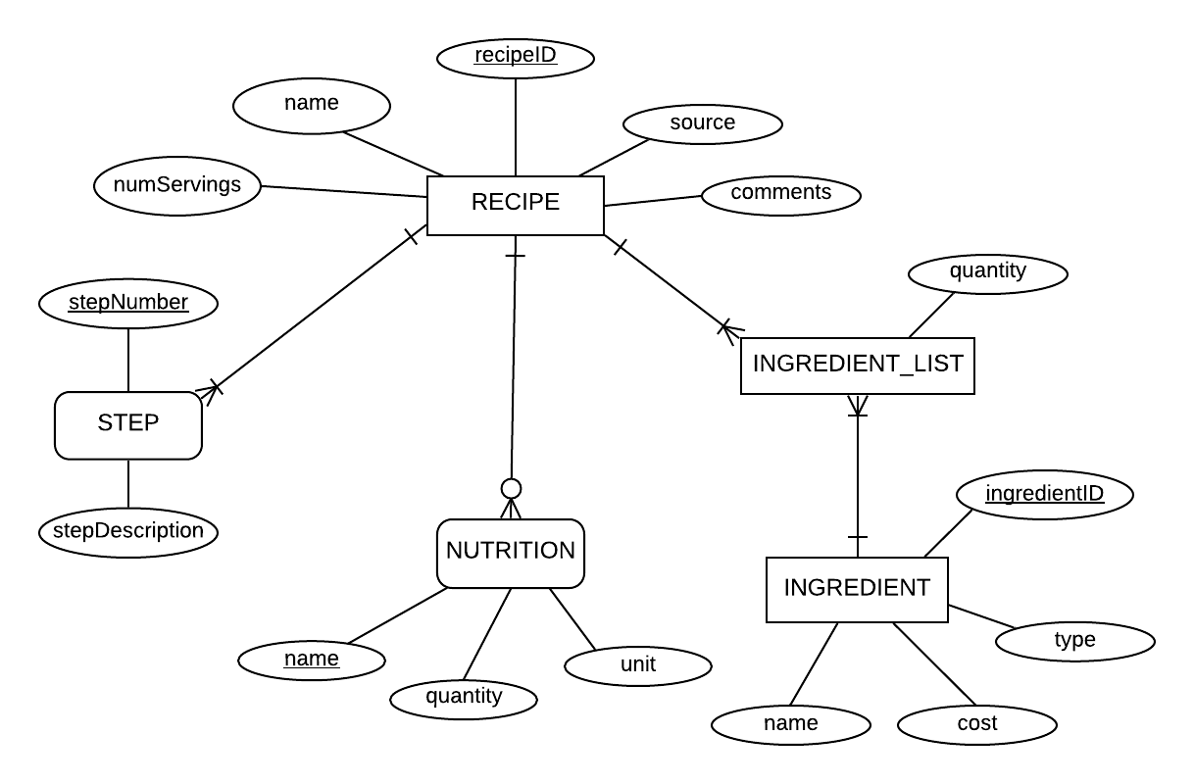

1. Mom is concerned that you’re not going to be able to cook traditional family meals. Show her that you have lots of her recipes stored in your database.

+--------------------+

| name |

+--------------------+

| Linguine Pescadoro |

| Zuppa Inglese |

+--------------------+

2 rows in set (0.00 sec)

1. You’ve invited friends for dinner, but they’re on a diet. Find the names of recipes that have fewer than 800 calories.

+----------------------+

| name |

+----------------------+

| Linguine Pescadoro |

| Zuppa Inglese |

| Crispy Fried Chicken |

+----------------------+

3 rows in set (0.00 sec)

1. You’re going to serve Beef Parmesan for dinner, however you don’t remember the full name of the recipe, so all you have to go on is ‘Beef Parmesan’. Create a shopping list (item name and quantity) of ingredients.

+------------------------------------+----------+

| name | quantity |

+------------------------------------+----------+

| beef cube steak | 1.5 |

| onion, sliced into thin rings | 1 |

| green bell pepper, sliced in rings | 1 |

| Italian seasoned bread crumbs | 1 |

| grated Parmesan cheese | 0.5 |

| olive oil | 0.125 |

| spaghetti sauce | 1 |

| shredded mozzarella cheese | 0.5 |

| angel hair pasta | 1 |

| garlic | 1 |

| butter | 0.125 |

+------------------------------------+----------+

11 rows in set (0.00 sec)

1. You’ve invited friends for dinner, but they’re vegetarian. You are going to use a subquery approach to find the names of recipies that are vegetarian. Your nested query will identify the recipeIDs from ingredient_list for ingredients that **have** a type of beef, pork, chicken, or lamb. The outer query will receive the recipeIDs, that include beef, pork, chicken, or lamb, from the subquery and will exclude those recipies from having their name displayed. **HINT**: First, try to get your "subquery" to return the recipieIDs from ingredient_list that contain an ingredient type of beef, pork, chicken, or lamb, and then add in the outer query to exclude those results from the recipe names that will be displayed.

+--------------------+

| name |

+--------------------+

| Linguine Pescadoro |

| Zuppa Inglese |

| Lobster Thermadore |

+--------------------+

3 rows in set (0.00 sec)

1. You feel like eating fish, but don’t want any heavy sauces like béarnaise. Find the names of your fish recipes that have fewer than 700 calories per serving. Make sure that the name of the recipe only appears once in the result set.

+--------------------+

| name |

+--------------------+

| Linguine Pescadoro |

+--------------------+

1 row in set (0.00 sec)

**Appendix A – Information on RECIPES database structure and content**

mysql> DESCRIBE recipe;

+-------------+--------------+------+-----+---------+-------+

| Field | Type | Null | Key | Default | Extra |

+-------------+--------------+------+-----+---------+-------+

| recipeID | int | NO | PRI | NULL | |

| source | varchar(60) | YES | | NULL | |

| comments | varchar(255) | YES | | NULL | |

| name | varchar(100) | YES | | NULL | |

| numServings | int. | YES | | NULL | |

+-------------+--------------+------+-----+---------+-------+

5 rows in set (0.00 sec)

mysql> DESCRIBE step;

+----------------+-------------+-----+-----+---------+------+

| Field | Type | Null| Key | Default |Extra |

+----------------+-------------+-----+-----+---------+------+

| stepNumber | int | NO | PRI | 0 | |

| stepDescription| varchar(255)| YES | | NULL | |

| recipeID | int | NO | PRI | 0 | |

+----------------+-------------+-----+-----+---------+------+

3 rows in set (0.01 sec)]

mysql> DESCRIBE nutrition;

+----------+--------------+------+-----+---------+-------+

| Field | Type | Null | Key | Default | Extra |

+----------+--------------+------+-----+---------+-------+

| name | varchar(100) | NO | PRI | | |

| quantity | double | YES | | NULL | |

| unit | varchar(20) | YES | | NULL | |

| recipeID | int | NO | PRI | 0 | |

+----------+--------------+------+-----+---------+-------+

4 rows in set (0.01 sec)

mysql> DESCRIBE ingredientList;

+--------------+---------+------+-----+---------+-------+

| Field | Type | Null | Key | Default | Extra |

+--------------+---------+------+-----+---------+-------+

| recipeID | int | NO | PRI | 0 | |

| ingredientID | int | NO | PRI | 0 | |

| quantity | double | YES | | NULL | |

+--------------+---------+------+-----+---------+-------+

3 rows in set (0.01 sec)

mysql> DESCRIBE ingredient;

+--------------+--------------+------+-----+---------+------+

| Field | Type | Null | Key | Default |Extra |

+--------------+--------------+------+-----+---------+------+

| ingredientID | int | NO | PRI | NULL | |

| name | varchar(100) | YES | | NULL | |

| cost | double | YES | | NULL | |

| type | varchar(20) | YES | | NULL | |

+--------------+--------------+------+-----+---------+------+

4 rows in set (0.01 sec)

mysql> SELECT * FROM recipe;

+----------+---------------+----------+--------------------------------------------+-------------+

| recipeID | source | comments | name | numServings |

+----------+---------------+----------+--------------------------------------------+-------------+

| 1 | julia Childs | | Beef Parmesan with Garlic Angel Hair Pasta | 4 |

| 2 | Mom | | Linguine Pescadoro | 4 |

| 3 | Mom | | Zuppa Inglese | 4 |

| 4 | Paul Prudhome | | Lobster Thermadore | 4 |

| 5 | Cooks.Com | | Crispy Fried Chicken | 4 |

+----------+---------------+----------+--------------------------------------------+-------------+

5 rows in set (0.00 sec)

mysql> SELECT * FROM step;

+------------+-------------------------------------------------------------------------------------------------------------------------------------------------------------------------------------------------------------------------------+----------+

| stepNumber | stepDescription | recipeID |

+------------+-------------------------------------------------------------------------------------------------------------------------------------------------------------------------------------------------------------------------------+----------+

| 1 | Preheat oven to 350 degrees F (175 degrees C). | 1 |

| 2 | Cut cube steak into serving size pieces. Coat meat with the bread crumbs and parmesan cheese. Heat olive oil in a large frying pan, and saute 1 teaspoon of the garlic for 3 minutes. | 1 |

| 3 | Quick fry (brown quickly on both sides) meat. Place meat in a casserole baking dish, slightly overlapping edges. Place onion rings and peppers on top of meat, and pour marinara sauce over all | 1 |

| 4 | Bake at 350 degrees F (175 degrees C) for 30 to 45 minutes, depending on the thickness of the meat. Sprinkle mozzarella over meat and leave in the oven till bubbly. | 1 |

| 5 | Boil pasta al dente. Drain, and toss in butter and 1 teaspoon garlic. For a stronger garlic taste, season with garlic powder. Top with grated parmesan and parsley for color. Serve meat and sauce atop a mound of pasta! | 1 |

| 1 | In a heavy saucepan over medium heat saute garlic in olive oil until garlic softens. | 2 |

| 2 | Add Italian seasoning, thyme, crushed red pepper flakes, crushed tomatoes, black olives, and the juice from both cans of clams. Simmer for 15 minutes. | 2 |

| 3 | Mix in canned clams, shrimp, scallops, lemon zest, and salt and pepper to taste. | 2 |

| 4 | Simmer for an additional 15 minutes or until shrimp and clams are cooked. | 2 |

| 5 | In a large pot of boiling salted water cook linguini until al dente. Drain. | 2 |

| 6 | Toss cooked and drained linguine pasta over seafood sauce. Serve warm. | 2 |

| 1 | Warm up the milk in a nonstick sauce pan | 3 |

| 2 | In a large bowl beat the egg yolks with the sugar, add the flour and combine the ingredients until well mixed. | 3 |

| 3 | Add the milk, a little bit at the time to the egg mixture, mixing well. | 3 |

| 4 | Put the mixture into the sauce pan and cook it on the stove at a medium low heat. Mix the cream continuously with a wooden spoon. When it starts to thicken remove it from the heat and pour it on a large plate to cool off. | 3 |

| 5 | Stir the cream now and then so that the top doesn't harden. | 3 |

| 6 | Dip quickly both sides of the lady fingers in the liquor. Layer them one at the time in a glass bowl large enough to contain 7 biscuits. | 3 |

| 7 | Spread 1/3 of the cream and repeat the layer with lady fingers. Finish with the cream. | 3 |

| 1 | Split the live lobsters in two, lengthwise. Crack the shell of the claws and remove the gills. | 4 |

| 2 | Season the lobster halves with salt and roast in the oven for 15-20 minutes. Remove and dice the flesh from the claws and tails. | 4 |

| 3 | Prepare the stock using equal portions of meat juices, fish fumet, and white wine flavored with chervil, tarragon and chopped shallots. | 4 |

| 4 | Boil it down to a concentrated consistency, then add heavy cream and English mustard. | 4 |

| 5 | Boil the sauce for a few minutes, then whisk in some fresh butter (cold cut into cubes and in 1/3 of the volume of the sauce). | 4 |

| 6 | Pour a little of this sauce in the shells of the lobsters. Fill the shells with the flesh of the lobsters. | 4 |

| 7 | Cover with the remainder of the sauce, sprinkle with a little Parmesan cheese and brown rapidly in a very hot oven. | 4 |

| 1 | Combine flour and seasonings in bowl. | 5 |

| 2 | Combine egg yolks and beer. | 5 |

| 3 | Add gradually to dry ingredients. | 5 |

| 4 | Heat oil in deep fryer to 365 degrees. | 5 |

| 5 | Moisten chicken pieces. Dip in seasoned flour, then batter, then back in seasoned flour. | 5 |

| 6 | Fry in hot oil 15 to 18 minutes until well browned. Drain on paper. | 5 |

+------------+-------------------------------------------------------------------------------------------------------------------------------------------------------------------------------------------------------------------------------+----------+

31 rows in set (0.00 sec)

mysql> SELECT * FROM nutrition;

+---------------+----------+----------+----------+

| name | quantity | unit | recipeID |

+---------------+----------+----------+----------+

| calories | 1167 | calories | 1 |

| carbohydrates | 45 | grams | 1 |

| fat | 23 | grams | 1 |

| protein | 32 | grams | 1 |

| calories | 532 | calories | 2 |

| carbohydrates | 59 | grams | 2 |

| fat | 12 | grams | 2 |

| protein | 29 | grams | 2 |

| calories | 612 | calories | 3 |

| carbohydrates | 45 | grams | 3 |

| fat | 49 | grams | 3 |

| protein | 4 | grams | 3 |

| calories | 1215 | calories | 4 |

| carbohydrates | 67 | grams | 4 |

| fat | 57 | grams | 4 |

| protein | 57 | grams | 4 |

| calories | 750 | calories | 5 |

| carbohydrates | 45 | grams | 5 |

| fat | 30 | grams | 5 |

| protein | 30 | grams | 5 |

+---------------+----------+----------+----------+

20 rows in set (0.00 sec)

mysql> SELECT * FROM ingredientList;

+----------+--------------+----------+

| recipeID | ingredientID | quantity |

+----------+--------------+----------+

| 1 | 1 | 1.5 |

| 1 | 2 | 1 |

| 1 | 3 | 1 |

| 1 | 4 | 1 |

| 1 | 5 | 0.5 |

| 1 | 6 | 0.125 |

| 1 | 7 | 1 |

| 1 | 8 | 0.5 |

| 1 | 9 | 1 |

| 1 | 10 | 1 |

| 1 | 11 | 0.125 |

| 2 | 6 | 0.125 |

| 2 | 10 | 2 |

| 2 | 18 | 1 |

| 2 | 22 | 1 |

| 2 | 23 | 0.5 |

| 2 | 24 | 0.25 |

| 2 | 25 | 0.25 |

| 2 | 26 | 1 |

| 2 | 27 | 1 |

| 2 | 28 | 0.125 |

| 2 | 29 | 0.25 |

| 2 | 30 | 0.25 |

| 2 | 31 | 1 |

| 2 | 32 | 1 |

| 3 | 13 | 4 |

| 3 | 15 | 2.5 |

| 3 | 16 | 0.75 |

| 3 | 17 | 21 |

| 3 | 18 | 1 |

| 3 | 20 | 0.5 |

| 3 | 21 | 1 |

| 4 | 5 | 0.125 |

| 4 | 9 | 0.25 |

| 4 | 21 | 1 |

| 4 | 33 | 1 |

| 4 | 34 | 2 |

| 4 | 35 | 1 |

| 4 | 36 | 1 |

| 4 | 37 | 1 |

| 4 | 38 | 0.125 |

| 4 | 39 | 0.25 |

| 4 | 40 | 0.25 |

| 5 | 10 | 1 |

| 5 | 13 | 1 |

| 5 | 20 | 2.5 |

| 5 | 23 | 0.125 |

| 5 | 31 | 0.125 |

| 5 | 32 | 0.25 |

| 5 | 41 | 3 |

| 5 | 42 | 0.125 |

| 5 | 43 | 0.5 |

+----------+--------------+----------+

52 rows in set (0.00 sec)

mysql> SELECT * FROM ingredient;

+--------------+------------------------------------+------+-----------+

| ingredientID | name | cost | type |

+--------------+------------------------------------+------+-----------+

| 1 | beef cube steak | 3 | beef |

| 2 | onion, sliced into thin rings | 0.5 | vegetable |

| 3 | green bell pepper, sliced in rings | 0.5 | vegetable |

| 4 | Italian seasoned bread crumbs | 0.1 | bread |

| 5 | grated Parmesan cheese | 5 | cheese |

| 6 | olive oil | 5 | oil |

| 7 | spaghetti sauce | 3 | sauce |

| 8 | shredded mozzarella cheese | 3 | cheese |

| 9 | angel hair pasta | 1 | pasta |

| 10 | garlic | 0.1 | vegetable |

| 11 | butter | 2 | oil |

| 12 | whole egg | 0.15 | egg |

| 13 | egg yolk | 0.15 | egg |

| 14 | egg white | 0.15 | egg |

| 15 | milk | 0.2 | dairy |

| 16 | sugar | 0.2 | sugar |

| 17 | biscuit | 0.2 | bread |

| 18 | lemon zest | 0.5 | fruit |

| 19 | orange zest | 0.5 | fruit |

| 20 | flour | 0.5 | bread |

| 21 | heavy cream | 1 | fat |

| 22 | linguini | 1 | pasta |

| 23 | Italian seasoning | 0.15 | herb |

| 24 | dried thyme | 0.15 | herb |

| 25 | red pepper flakes | 0.15 | herb |

| 26 | crushed tomatoes | 1 | vegetable |

| 27 | black olives | 1 | vegetable |

| 28 | baby clams | 3 | fish |

| 29 | salad shrimp | 10 | fish |

| 30 | scallops | 8 | fish |

| 31 | salt | 0.01 | herb |

| 32 | black pepper | 0.05 | herb |

| 33 | fish fumet | 10 | fish |

| 34 | lobster | 18 | fish |

| 35 | bouillon | 1 | sauce |

| 36 | white wine | 10 | wine |

| 37 | chervil | 10 | wine |

| 38 | tarragon | 5 | herb |

| 39 | shallots | 3 | vegetable |

| 40 | mustard | 2 | condiment |

| 41 | whole chicken | 1.75 | chicken |

| 42 | paprika | 5 | herb |

| 43 | beer | 1 | alcohol |

+--------------+------------------------------------+------+-----------+

43 rows in set (0.00 sec